openEuler riscv - Docker安装和功能测试

1. qemu启动openEuler

sudo apt install gedit

gedit run.sh

qemu-system-riscv64 \

-nographic -machine virt \

-smp 2 -m 4G \

-kernel fw_payload_oe_docker.elf \

-drive file=openEuler-preview.riscv64.qcow2,format=qcow2,id=hd0 \

-object rng-random,filename=/dev/urandom,id=rng0 \

-device virtio-rng-device,rng=rng0 \

-device virtio-blk-device,drive=hd0 \

-device virtio-net-device,netdev=usernet \

-netdev user,id=usernet,hostfwd=tcp::22222-:22 \

-append 'root=/dev/vda1 rw console=ttyS0 systemd.default_timeout_start_sec=600 selinux=0 highres=off mem=2048M earlycon' \

-bios none

二、登录

用户名：root

密码：openEuler12#$

1. 修改时间

date --set YYYY-MM-DD

date --set HH:MM:SS

1. 增加dnf repo

（一）修改配置

Vim /etc/dnf/dnf.repo

新增如下内容

[repository]

name=openEuler

baseurl=http://121.36.3.168:82/home:/pandora/openEuler_stage1/

enabled=1

gpgcheck=1

gpgkey=http://121.36.3.168:82/home:/pandora/openEuler_stage1/repodata/repomd.xml.key

[repository1]

name=RISCV

baseurl=http://119.3.219.20:82/openEuler:/Mainline:/RISC-V/standard_riscv64/

enabled=1

gpgcheck=1

gpgkey=http://119.3.219.20:82/openEuler:/Mainline:/RISC-V/standard_riscv64/repodata/repomd.xml.key

[repository2]

name=docker

baseurl=http://121.36.3.168:82/home:/pandora:/docker/standard_riscv64/

enabled=1

gpgcheck=1

gpgkey=http://121.36.3.168:82/home:/pandora:/docker/standard_riscv64/repodata/repomd.xml.key

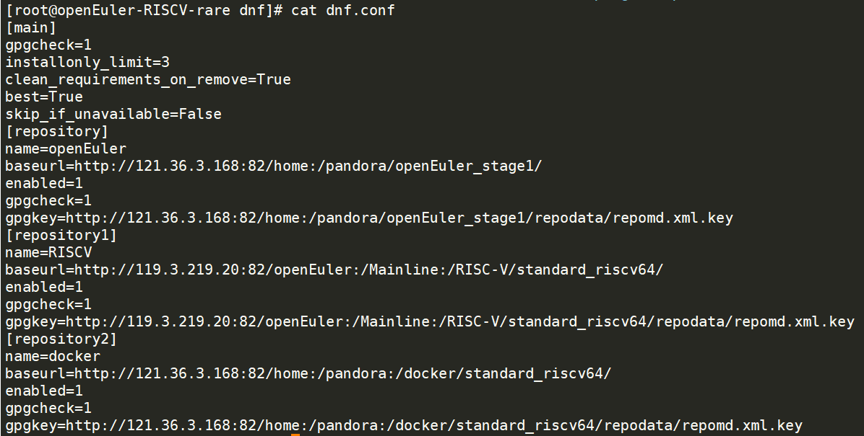

（二）是否成功

命令

dnf repolist

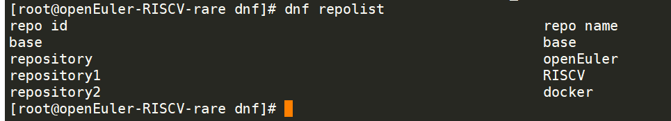

（三）如上图，添加成功，安装需要的包

dnf install docker

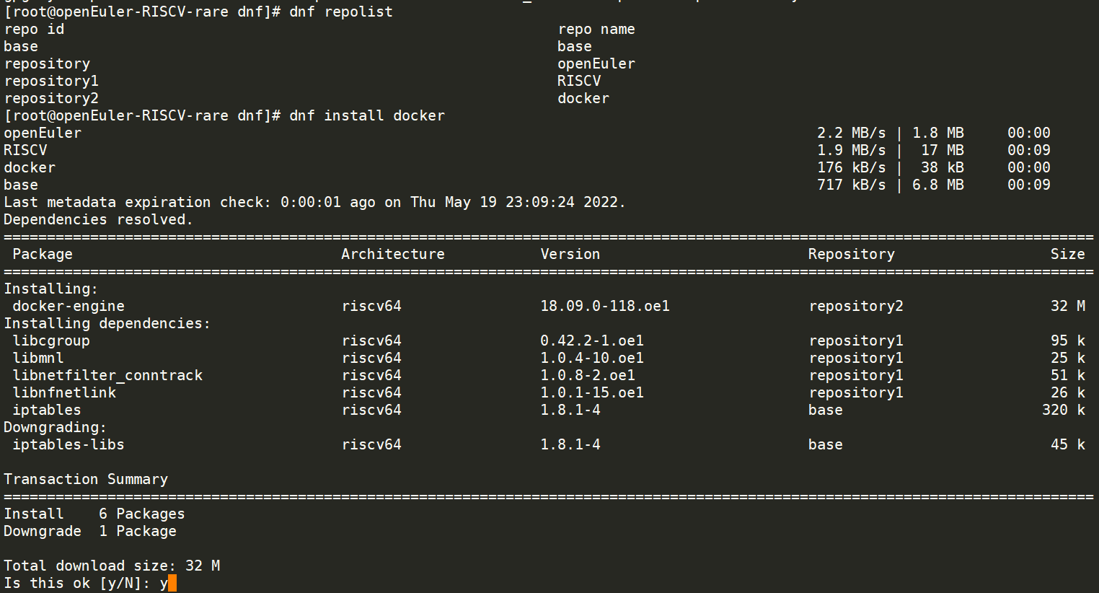

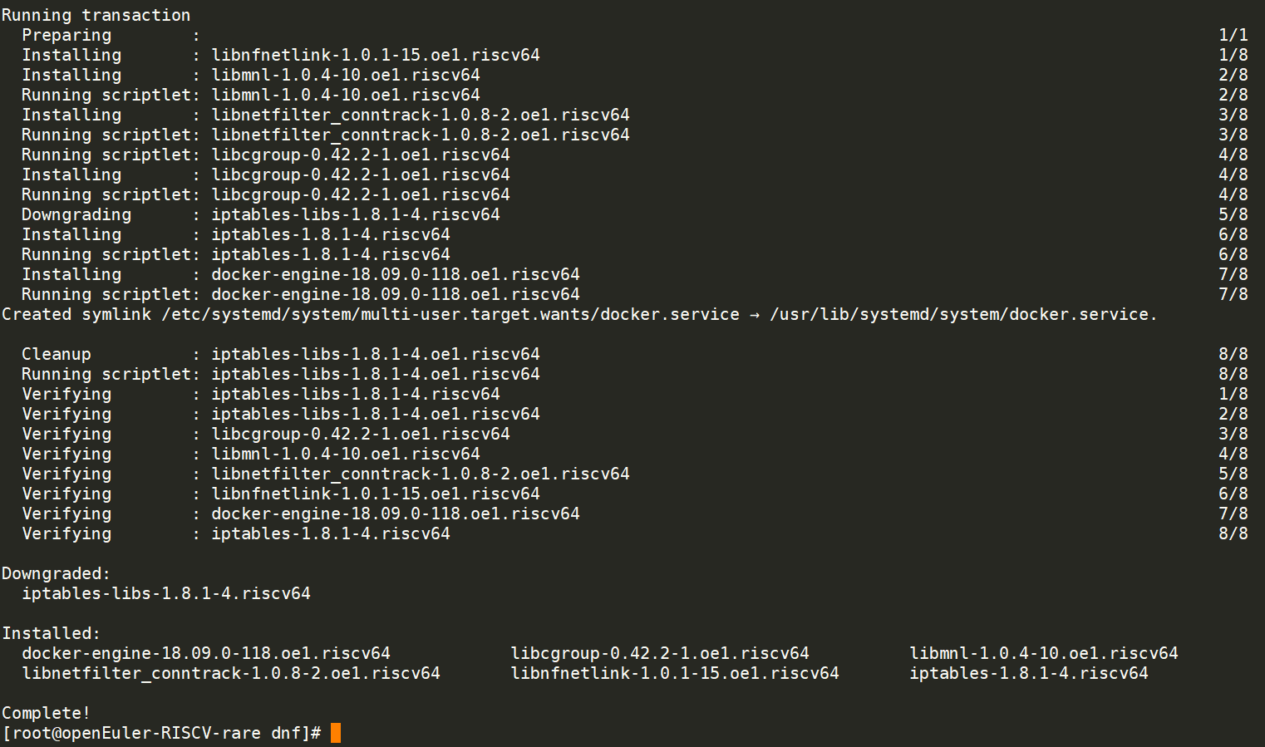

（四）查看docker是否安装成功

docker -v

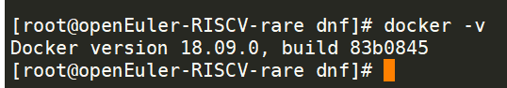

1. 测试docker

docker pull hello-world

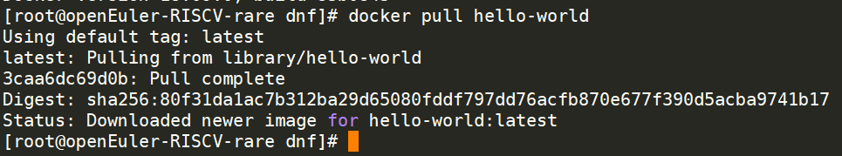

docker images

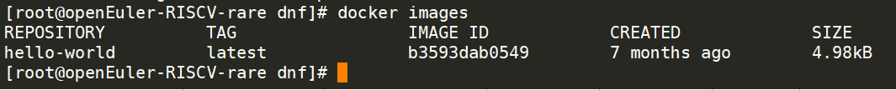

docker run hello-world

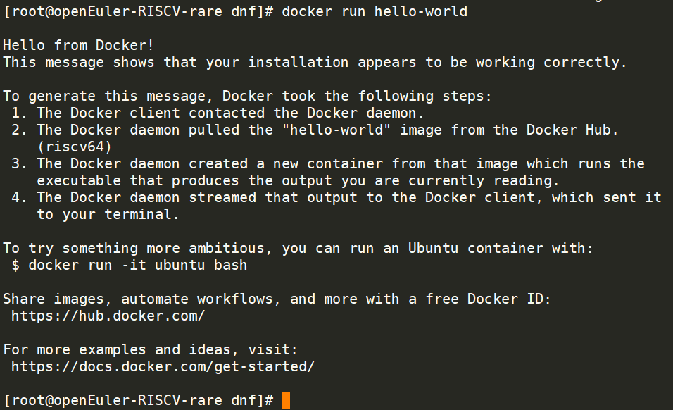

1. ubuntu镜像测试

拉去镜像

docker pull ubuntu

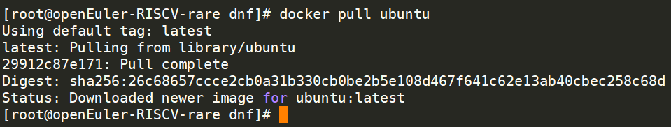

docker images

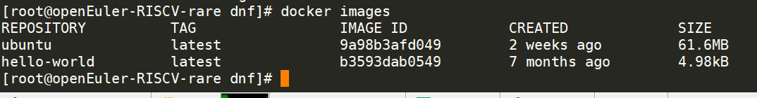

docker run -it ubuntu /bin/bash

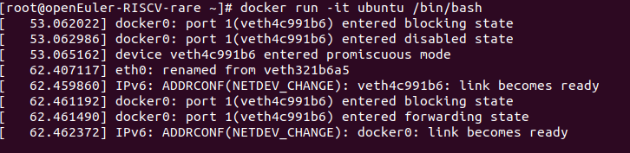

启动一晚上ubuntu也没起来